Business Architect
Outcomes Skills and Competencies
Vayase Consulting
v0.1

Table of Contents
2 Introduction 3
3 Business Architect Role Outcomes 3
3.1 Stakeholder Satisfaction 3
3.2 Strategic Business Alignment 4
3.3 Business Transparency 4
3.4 360 degree Decision Making 4
4 Business Architecture Skill to Outcome Mapping 4

Introduction
The purpose of this document is to describe with rational the competencies necessary for the role of a business architect. This work draws from and contributes to the work that has currently been undertaken by the Business Architecture Guild, IEEE and FEAPO. This paper does not delve into the detail around the deliverables that the role has to produce, as these will vary from organization to organization, and according to the methods that are used to perform Business Architecture.

Business Architect Role Outcomes
There is one core outcome for the Business Architect role and this is BUSINESS VALUE. The rationale is simply that if the Business Architect does not deliver acknowledged and perceived value then the role is recognized as being of “no use” to the organization concerned. There are three main contributing outcomes that usually result in perceivable Business Value. These are:
Figure 1 Business Architect Outcomes
- Stakeholder Satisfaction
- Strategic Business Alignment
- Business Transparency
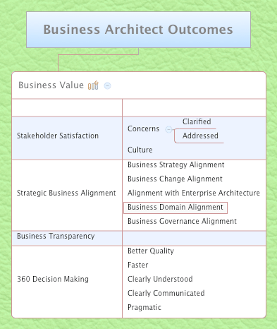
- 360 degree Decision Making
These outcomes are described in the Figure 1:

These four outcomes sum the core outcomes that a Business Architect must deliver so as to be considered as delivering tangible business value. The emphasis of these outcomes within a given business will vary depending on the environment, culture, focus and maturity of the business at a given time. They will however always be in full operation throughout the life of the business.

Stakeholder Satisfaction
This outcome is of primacy to all of the activities of a Business Architect. The role of a Business Architect involves dealing with management regularly and at all levels in the Business. This makes the Business Architect particularly vulnerable to and reluctantly participative in Organizational politics, culture and behavior. This therefore requires that the Business Architect be able to achieve a good level of stakeholder satisfaction or else lose credibility, cooperation and the associated effectiveness. In short despite achieving stellar results due to the activities of the Business Architect, if stakeholders are not satisfied with the results, the Business Architect is in peril.

Strategic Business Alignment
This outcome is what a Business Architect has to achieve in order to drive tangible value within the business. In short when using Business Architecture to align Marketing and Operations execution and change initiatives, the Business Architect achieves tangible results in the delivery of initiatives operating under the alignment regime

Business Transparency
This outcome drives Business Value for a Business Architect by Business Architecture establishing documented relationships between concepts across the business and using these to drive a better understanding of the impacts that a business will face it takes various courses of action.

360 degree Decision Making
This outcome is where by the Business Architect enables Highly effective all round decision making that is informed, rapid and clear. This outcome is important because a large part of the Business Architects role is advisory to management.

Business Architecture Skill to Outcome Mapping
TBD

